01.07 Reliability
Process Design & AMOS Configuration Document
Purpose
This Process Design document is provided to Key-Users to record their key decisions regarding the AMOS Process design and the required AMOS configuration.
It is updated throughout the Project Definition Phase and used as the baseline for the Final Acceptance prior to Go-Live
Revision
Author, Name | Date | Notes
Pradeep Pathirana | 31.May 2024 | 1. version
Pradeep Pathirana | 10.December 2024 | 2. version

Table of Contents
1. Process Overview & Objectives 3
2. Regulatory References 3
3. Definitions & Glossary 3
4. Process Tasks 3
5. Process Dependencies 4
6. Process Flow 5
7. Process Design Questions 6
8. Data (Source) Mapping 8
9. Other Software Used 8
10. AMOS Configuration 9
a. Basic Data 9
b. Parameters 9
c. Workflows 10
d. Scheduled Tasks 11
e. API’s & Interfaces 12
11. UAT Guidance 12
12. Annex – Additional Info 12

Process Overview & Objectives

Process General Description:
This process allows to identify data sources for Reliability Reporting.
Reliability data is successful collected, analysed and utilised by aircraft operator, airframe, engine and component manufacturers world-wide every day. Aircraft hours & landings, aircraft logbook, aircraft events, scheduled maintenance data, shop findings, LRU removals, service bulletin / modification incorporation, out of service information, part quantity per aircraft and other related information are getting more and more important in terms of airworthiness, safety and service level.
Main Process Objectives:
- Definitions
Before starting with the different reliability programs, it is necessary to define the basic settings for the aircraft types to be managed in the reliability module. It is allowed to create multiple aircraft groups, which helps to benchmark from different perspectives by creating various groups.
Examples: A320, A330, B737, B787, Airbus Fleet, Boeing Fleet, Summer OPS, Narrow Body Fleet

- Dispatch Reliability
Technical Dispatch Reliability data is displayed in both table and graphic formats. Operators can issue reports to assess fleet performance regarding technical delays, cancellations, and their causes.
- System Reliability
Systems Reliability is used to analyse unscheduled work orders, such as maintenance defects and pilot reports, with a focus on exceedances.

- Scheduled Maintenance Finding
Maintenance Findings Reporting evaluates issued findings for events and assesses the efficiency of the maintenance program.

- Parts Reliability
Part Reliability tracks the performance of components, calculates the MTBUR, MTBF, and failure rate, and compares them with upper control values. It allows the identification of rogue units that fail frequently in a short period. Identified suspicious parts can be marked in the system and blocked from future use.

- Technical Case Manager

The Technical Case Manager is a comprehensive tool used to manage technical issues for single aircraft or entire fleets. It allows for the collection the operation interruptions, unscheduled maintenance actions, removals, and all related data in one place for proper root cause analysis. Once root causes are identified, solutions can be documented here, enabling the calculation of the return on investment of the solution. Furthermore, system deficiency reports can be generated and printed.

- Creating Reliability Reports:
Reports such as Systems Reliability, Part Reliability Report, Technical Dispatch Reliability Report, Suspicions Part Report, Rogue Unit Report, and Testcards Findings Report could be printed using its own program. The Reliability Report Builder allows for the collection of all reliability-related data and enables exporting them to create the customer's own reliability reports. Comprehensive reports could be designed with the report designer.

Regulatory References

Definitions & Glossary

Key-Words | Explanation
MTBF | Meantime between failure
MTBUR | Meantime between unscheduled removals
NFF | No Failure Found
NORELB | Excludes Parts from the Part Reliability calculations (no Reliability)

Process Tasks

Business Process Task / Actions / Activities:
- define basic settings for the aircraft types and include the aircrafts to the groups.
- Create reliability reports (Dispatch-, Systems-, Parts Reliability and Findings)
- Create the technical cases and investigate the fleet issues.

Process Dependencies

- 01.03 Maintenance Program
- 01.06 MEL Administration
- 01.09 Powerplants (Engine/APU)
- 06.02 Delays & Event Tracking
- 08.02 Performing Maintenance
- 08.04 Parts Removal & Installation

Process Flow
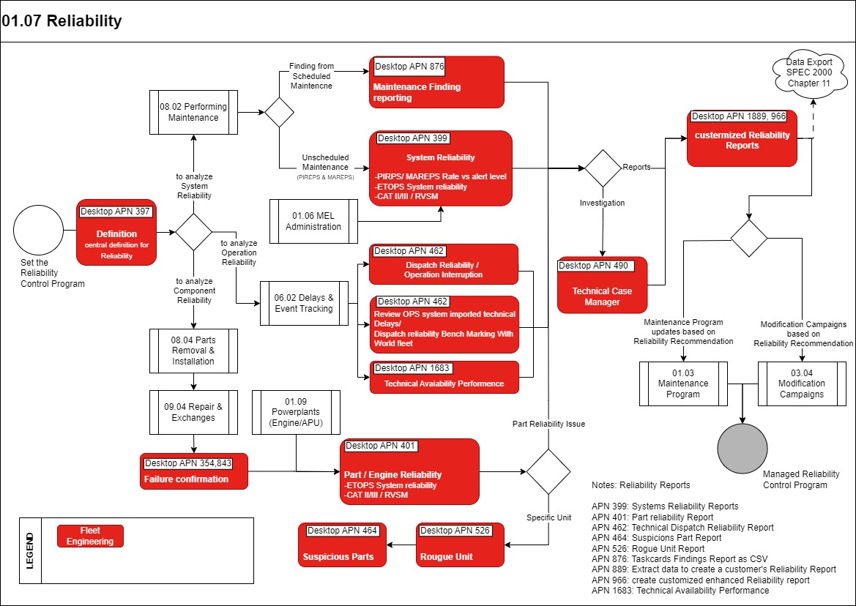

Process Design Questions

# | Question | Answer
Q1 | Do you perform a statistical analysis or not?
Q2 | To which ATA Chapter level will defects/Pireps be recorded?
Q3 | Which data do you collect? Which graph?  Hand out your report to S-AS and match reports and data in AMOS.
Q4 | How do you have to follow up reliability problems?  Will you use the Technical Case Manager (APN: 490) to follow up problems discovered by the Reliability (statistical or not) analysis and will you use it together with the Severity Factor?
Q5 | Which data do you look at for Components Reliability?
Q6 | Are there reliability programs for APU In-flight start, CAT II verification? How are these currently managed?

Data (Source) Mapping

Data Sources | Description | Volume / Manual / Automatic / Static / Dynamic

Other Software Used

Other Softwares | Used by: | Description

AMOS Configuration

Basic Data

Basic Data Table | Notes
Delay Code | “SPEC 2000 Delay Code” should contain a valid IATA/ICAO Delay code

Parameters

Parameter Code | Parameter Name | Notes
1276 | ROI MAINT. COST FORMULA
1277 | ROI INT. COST FORMULA
1679 | Link Master and Reference Workorder with Workorder folder

Workflows

Workflow Number | Workflow Name | Notes
78 | Review date due | Related to Technical Case Manager

Scheduled Tasks

Scheduled Task Reference | Frequency | Notes
CaseReviewNotificationTask

API’s & Interfaces

Reference / Interface | Trigger
 | NIL

UAT Guidance

UAT No | Proposed User Acceptance Test Scenario

Annex – Additional Info

